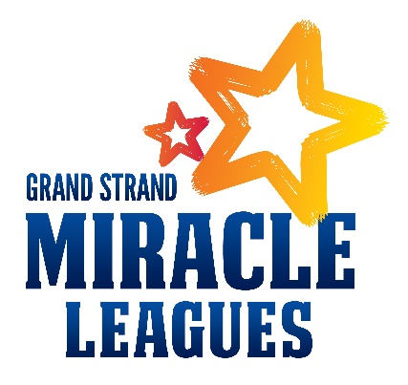

Visiting Groups Waiver of Liability

I will be participating in sports activities at the Grand Strand Miracle League field, 690 33rd Avenue North, Myrtle Beach, SC, and do hereby release any liability for injury that may occur to my body or property while participating as a player or spectator during the activities.

I hereby grant the Grand Strand Miracle Leagues, its affiliates, franchises, advertising and promotional agencies, and their agents, the irrevocable, unrestricted right to use, publish, display and distribute materials bearing my name, voice, likeness or any other identifiable representation of myself, my family members including my Miracle Leagues player/child. These materials may appear in any form, style color or medium whatsoever (including, without limitation, photographs, video tapes, films sound recordings, software, drawings, prints, broadcast, internet, and electronic media.) I agree that all material containing any identifiable representation of me (including without limitation, all negatives, plates and masters of any photographs, files, prints or tapes) shall be and remain the sole and exclusive property of the GSML. I hereby release and forever discharge the GSML from all liability and damages relating to the use of my name, voice, likeness, or any other identifiable representation of me.

I have agreed to the above in consideration of the opportunity given to me by The Grand Strand Miracle Leagues to appear in these materials. I acknowledge that I have fully read and understand this document and that I have had any questions regarding its effect, or the meaning of its terms answered to my satisfaction. I certify that I am at least 18 years of age unless this document is also signed by my parent or legal guardian.

Print Name_________________________________________________

Signature___________________________________________________

Date______________________________

